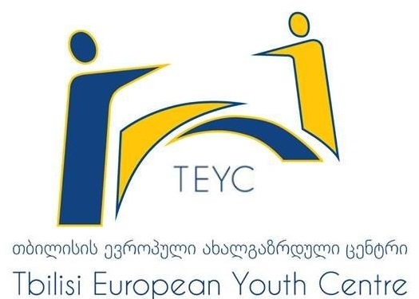

Eastern Partnership International Youth Camp
September 13–19, 2015

Expression of Interest

“Tbilisi European Youth Centre”
of the Tbilisi Municipality City hall

Expression of Interest for Eastern Partnership International Youth Camp

Information about applicant
- Name: Click here to enter text.
- Surname: Click here to enter text.
- Age: Click here to enter text.
- Date of birth: Click here to enter text.

Contact Information
- Address:Click here to enter text.
- City\Village: Click here to enter text.
- E-mail: Click here to enter text.
- Contact Phone: Click here to enter text.
- Special needs (Do you have any special needs? e.g: disability, special dietary and etc.):Click here to enter text.
- Are you available to attend the whole duration of the Camp?
Yes☐ No☐
- Are you available to work in English?
Yes☐ No☐

Organization:
- Are you any representing any organization? Yes☐ No☐
If yes, please indicate:
- Name of Organization: Click here to enter text.
- Address and Contact information (E-mail, phone number ) Click here to enter text.
- Short description on your organization’s activities:Click here to enter text.
- Beneficiaries of your organization? Click here to enter text.
- Where is your organization implementing different initiatives? Click here to enter text.
- What is your role in this organization Click here to enter text.

If no, please indicate:
What are you occupied with? (for example: youth worker, student and other.)?Click here to enter text.

Knowledge and Experience
- What do you think about the Eastern Partnership Program of the European Union and how important it is for countries and people in your opinion? Click here to enter text.

- What do you think how important is young people’s involvement in the different processes of, and why? Click here to enter text.

- Have you ever participated is this kind of activities? If yes, please indicate: Click here to enter text.

Motivation and Expectations:

- Why do you want to participation in the Camp?Click here to enter text.

- What do you expect from the camp? Click here to enter text.

- How can you contribute to the process of successful implementation of the camp? Click here to enter text.

Filled applications must be sent to the e-mail address TEYC.Info@gmail.com
No later than 28th of August 2015
Good Luck

